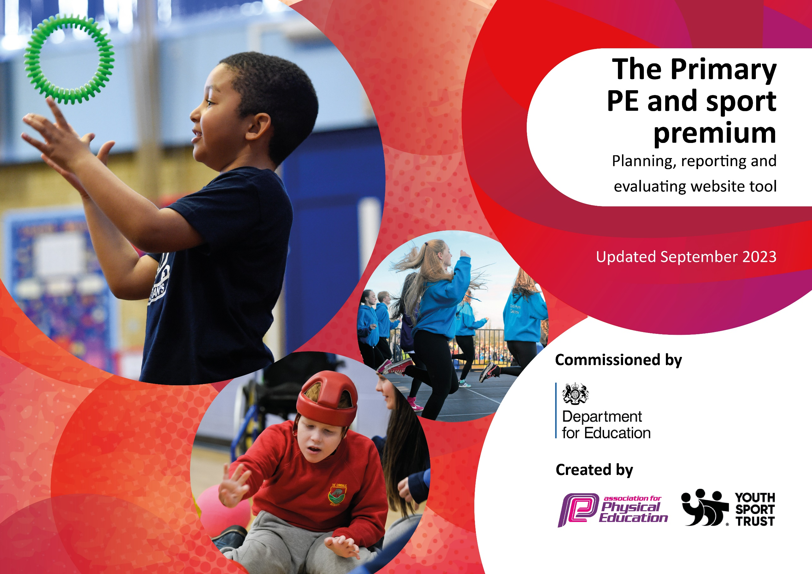

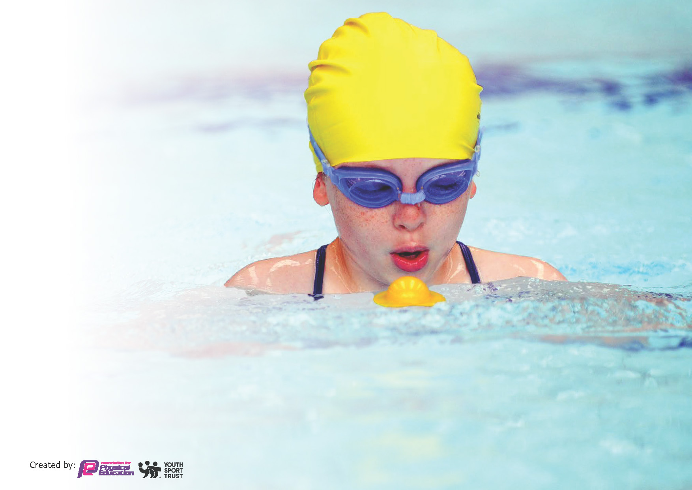
This template can be used for multiple purposes:
by:
- It enables schools to effectively plan their use of the Primary PE and sport premium
- It helps schools to meet the requirements (as set out in guidance) to publish information on their Primary PE and sport premium
- It will be an effective document to support Ofsted inspections enabling schools to evidence progress in Physical Education (PE) and evidence swimming attainment, which forms part of the PE National Curriculum. We would recommend schools consider
the Intent, Implementation and Impact of any spend, as examined within the Education Inspection Framework.

It is important that your grant is used effectively and based on school need.

Schools must use the funding to make additional and sustainable
improvements to the quality of the PE, School Sport and Physical Activity (PESSPA)
they offer. This means that you should use the Primary PE and sport premium to:

- Build capacity and capability within the school to ensure that improvements made now will benefit pupils joining the school in future years
- Develop or add to the PESSPA activities that your school already offers.

The Primary PE and sport premium should not be used to fund capital spend projects; the school’s core budget should fund these. Further detail on capital expenditure can be found in the updated Primary PE and sport premium guidance.

The Primary PE and sport premium guidance, outlines 5 key priorities that funding should be used towards. It is not

necessary that spending has to meet all the key priorities, you should select the priorities that you aim to use any funding towards.

Although completing this template is not a requirement for schools, schools are required to publish details of how they spend this funding. Schools must also outline what the impact this funding has had on pupils’ PE and sport participation and attainment and how any spending will be sustainable in the future. All funding must be spent by 31st July 2024.

The Department for Education has worked closely with the Association for Physical Education (afPE) and the Youth Sport Trust (YST) to develop this template and encourages schools to use it. This template is an effective way of meeting the reporting requirements of the Primary PE and sport premium.
Review of last year’s spend and key achievements (2022/2023)

We recommend you start by reflecting on the impact of current provision and reviewing your previous spend.

Activity/Action | Impact | Comments
Increased activities to provide increased opportunities for students to undertake 30 mins of PA per day;  - Lunchtime clubs (every day)  - Breakfast club (every day)  - After-school club (every day)  All are staffed by PE lead and teaching assistants  Increased profile of PE; Increased breadth of study – new sports added to PE curriculum to increase engagement and link to extra-curricular opportunities (and sign posting to community providers).  Assemblies used as platform to promote successes/attendance to Sports Clubs.  Cross-curricular links established with different subjects to support advocacy of PE.  Year 6 Play leaders / Playground equipment and provision to promote active lunchtimes.  Staff knowledge / confidence; team teaching PE lessons, TA’s support in all PE lessons (to upskill staff)  Increased engagement in competitive sports.  - Schools Games  - Norfolk Competitions  - Thetford Primary cluster sports events | Increased participation  After-school clubs are at capacity  Participation numbers  Each term 100 students ASC every day  OAA now established / re-developed on the PE curriculum. Increased breadth of ‘Games’ activities are now provided to cater for more students needs/interests – with a large focus on engaging community settings to encourage transit to clubs.  Olympics used as a platform to engage students in lessons beyond PE and trying new sports (such as Badminton)  8 leaders (students) have received significant training to support lunchtime supervisors in creating more activity on playground during lunchtime. This has created a culture of children playing recreationally/informally during social times.  High quality PE lessons, with students reporting increased enjoyment and participation within lessons.  TA support ensures lessons are inclusive, with significant SEND needs catered for in practical lessons.  Increased competitive opportunities have been a key focus this year, with successes such as;  - All year 3 and 6 students competed within inter-school cricket competitions  - Large numbers of Year 3 and 4 students represented the school in Football | Funding used to provide equipment to increase breadth of activities.  Teaching assistants have been upskilled to supervise/lead basic activities (with an aim of increasing capacity to cater for more students).  Recent success with Thetford Rugby Club and Thetford Cricket Club. Key priority to explore Thetford Gymnastics club next academic year.  Significant funding was used to fund new equipment which is easily accessible / safe / fit-for-purpose.  Next steps – PE lead to do Level 3 Forest School qualification.  Continue to upskill TAs – raising competence/confidence to deliver practical interventions to small groups during PE lessons.  Next steps – increased number of competitive / development opportunities to allow more students to represent the school in a sports environment (Eg. Netball, girls football, Dance, Cricket, OAA, and swimming)

Key priorities and Planning
This planning template will allow schools to accurately plan their spending. 2023 – 2024 PE Premium Allocation - £17,920

Action – what are you planning to do | Who does this action impact? | Key indicator to meet | Impacts and how sustainability will be achieved? | Cost linked to the action
Increased breadth of study within PE curriculum and extra-curricular activities offered.  Introduce lunchtime sport sessions/activities for pupils.  Introduce new / further develop existing extra-curricular sport sessions/activities for pupils after school  CPD for staff – external staff to upskill teachers/support staff. | PE Lead  Teaching staff  Teaching Assistants  Lunchtime supervisors  Students – All year groups  Lunchtime supervisors / staff, coaches - as they need to lead the activity  Students – All year groups, different year groups each day (2 lunch sessions per day).  5 after school sessions per week introduced.  Different activities each half term (chosen by student council) – external expertise needed to upskill staff in new activities. | - increasing all staff’s confidence, knowledge and skills in teaching PE and sport  - increasing engagement of all pupils in regular physical activity and sport  - raising the profile of PE and sport across the school, to support whole school improvement  - offer a broader and more equal experience of a range of sports and physical activities to all pupils  - increase participation in competitive sport  - increasing all staff’s confidence, knowledge and skills in teaching PE and sport  - increasing engagement of all pupils in regular physical activity and sport  - raising the profile of PE and sport across the school, to support whole school improvement  - offer a broader and more equal experience of a range of sports and physical activities to all pupils | Increased number of students taking part in inter-school competitions (Thetford Primary cluster events – low-stake / high participation)  Increased confidence / competence of PE staff  More pupils meeting their daily physical activity goal, more pupils encouraged to take part in PE and Sport Activities.  Significant impact on improved behaviour – students are active during social times which decreases antisocial/poor behaviour, whilst the provision also improves focus/behaviour in afternoon lessons.  Existing staff supporting extra-curricular are upskilled in new activities | £2000 on equipment linked to new sports / increased competition.  Eg. £100 – Netball bibs, £1000 Portable football goals.  £500 - Bespoke line markings on field (this is in addition to our usual groundskeeping / line marking as it was new and extra lines for new sports eg. Smaller sided games / grids / etc.)  £3,750 – Staff capacity

Before school physical activity interventions.  Participation / strategic oversight of a new inter-school sports partnership | Staff – improving behaviour across the school with increased PA being offered to students.  Students – targeted interventions which focus on our most disadvantaged / cared for students.  PE lead  Teaching assistants – upskilled via events / increased opportunities to teach PE lessons.  Students – engagement / development / competitive events targeting different demographics. | - increasing engagement of all pupils in regular physical activity and sport  - raising the profile of PE and sport across the school, to support whole school improvement.  - increasing engagement of all pupils in regular physical activity and sport  - raising the profile of PE and sport across the school, to support whole school improvement.  - increase participation in competitive sport | Improvements in behaviour / attendance (particularly punctuality) / and attainment.  Our PE lead has been given capacity to liaise / collaborate with other local primary PE leads to create a new competitive sports calendar for all schools within our area. This has included competitions, as well as ‘festival’ style events to engage more young people in PA. | £6250  £4,820 – Staff capacity

Key achievements 2023-2024
This template will be completed at the end of the academic year and will showcase the key achievements schools have made with their Primary PE and sport premium spending.

Activity/Action | Impact | Comments
All Year 6 students have attended at least one sporting inter-school enrichment opportunity to represent their school.  Successful implementation of ‘Thetford Sports Network’ Primary school events, all organised and led by Redcastle Family School.  Increased engagement in physical activity following a creative PA club – using literacy as a key focus | Building a culture in school where young people are proud of their school and want to take part in competitive opportunities.  A minimum of at least 1 event over half term has been delivered for all 6 Primary schools within the town, with a focus to ensure all year groups participate in at least one event per academic year.  Using Harry potter as a stimulus – the school have created a Quiddich club, to engage different young people in PA, as well as linking to literacy/English. | All events were organised by the PE leads at RFS, with a sustainability plan of trying to upskill over PE leads to lead/contribute to future events.  This was led by one of our Teaching assistants, who has been upskilled via working closely with our breakfast club providers.

Swimming Data
Meeting National Curriculum requirements for swimming and water safety.
Priority should always be given to ensuring that pupils can perform safe self-rescue even if they do not fully meet the first two requirements of the National Curriculum programme of study

Question | Stats: | Further context  Relative to local challenges
What percentage of your current Year 6 cohort can swim competently, confidently and proficiently over a distance of at least 25 metres? | 30% | We have had to limit the number of pupils attending swimming lessons during Covid which means some pupils have attended fewer swimming lessons than others.  Young people do not have access to swimming in their own time, and families have financial constraints due to the prices in our local leisure centre.
W

What percentage of your current Year 6 cohort are able to perform safe self-rescue in different water-based situations? | % | Use this text box to give further context behind the percentage.
If your schools swimming data is below national expectation, you can choose to use the Primary PE and sport premium to provide additional top-up sessions for those pupils that did not meet National Curriculum  requirements after the completion of core lessons. Have you done this? | No | We have not been able to achieve this due to access to the local leisure Centre / times swimming teachers were available. We have plans in place to explore top-up provision next year.  We also face significant barriers re: transport costs to and from school to get to our nearest swimming pool.
Have you provided CPD to improve the knowledge and confidence of staff to be able to teach swimming and water safety? | No

Signed off by:

Head Teacher: | (Name)
Subject Leader or the individual responsible for the Primary PE and sport premium: | (Name and Job Title)
Governor: | (Name and Role)
Date:

